URL01:

<https://github.com/lqdung95ntp/CircleCI_Udacity>

URL02:

<http://udapeople-46fd16f.s3-website-us-east-1.amazonaws.com/>

SCREENSHOT01:

SCREENSHOT02:

SCREENSHOT03:

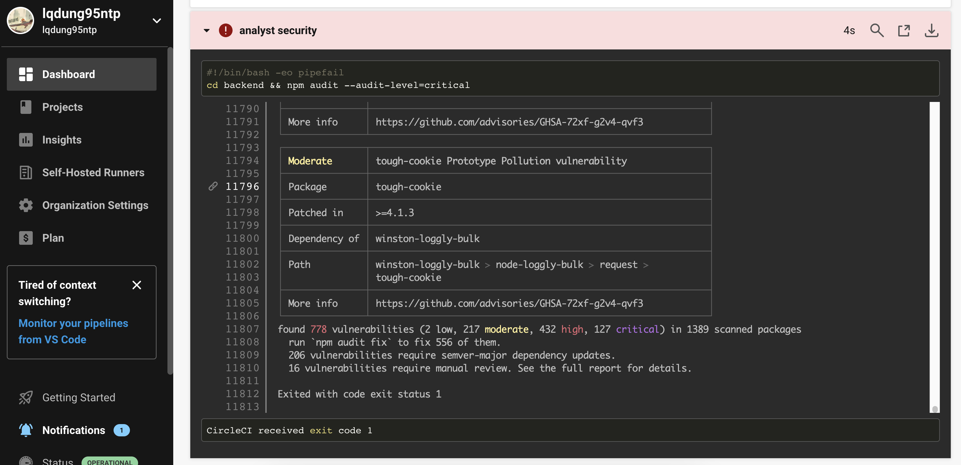

SCREENSHOT04:

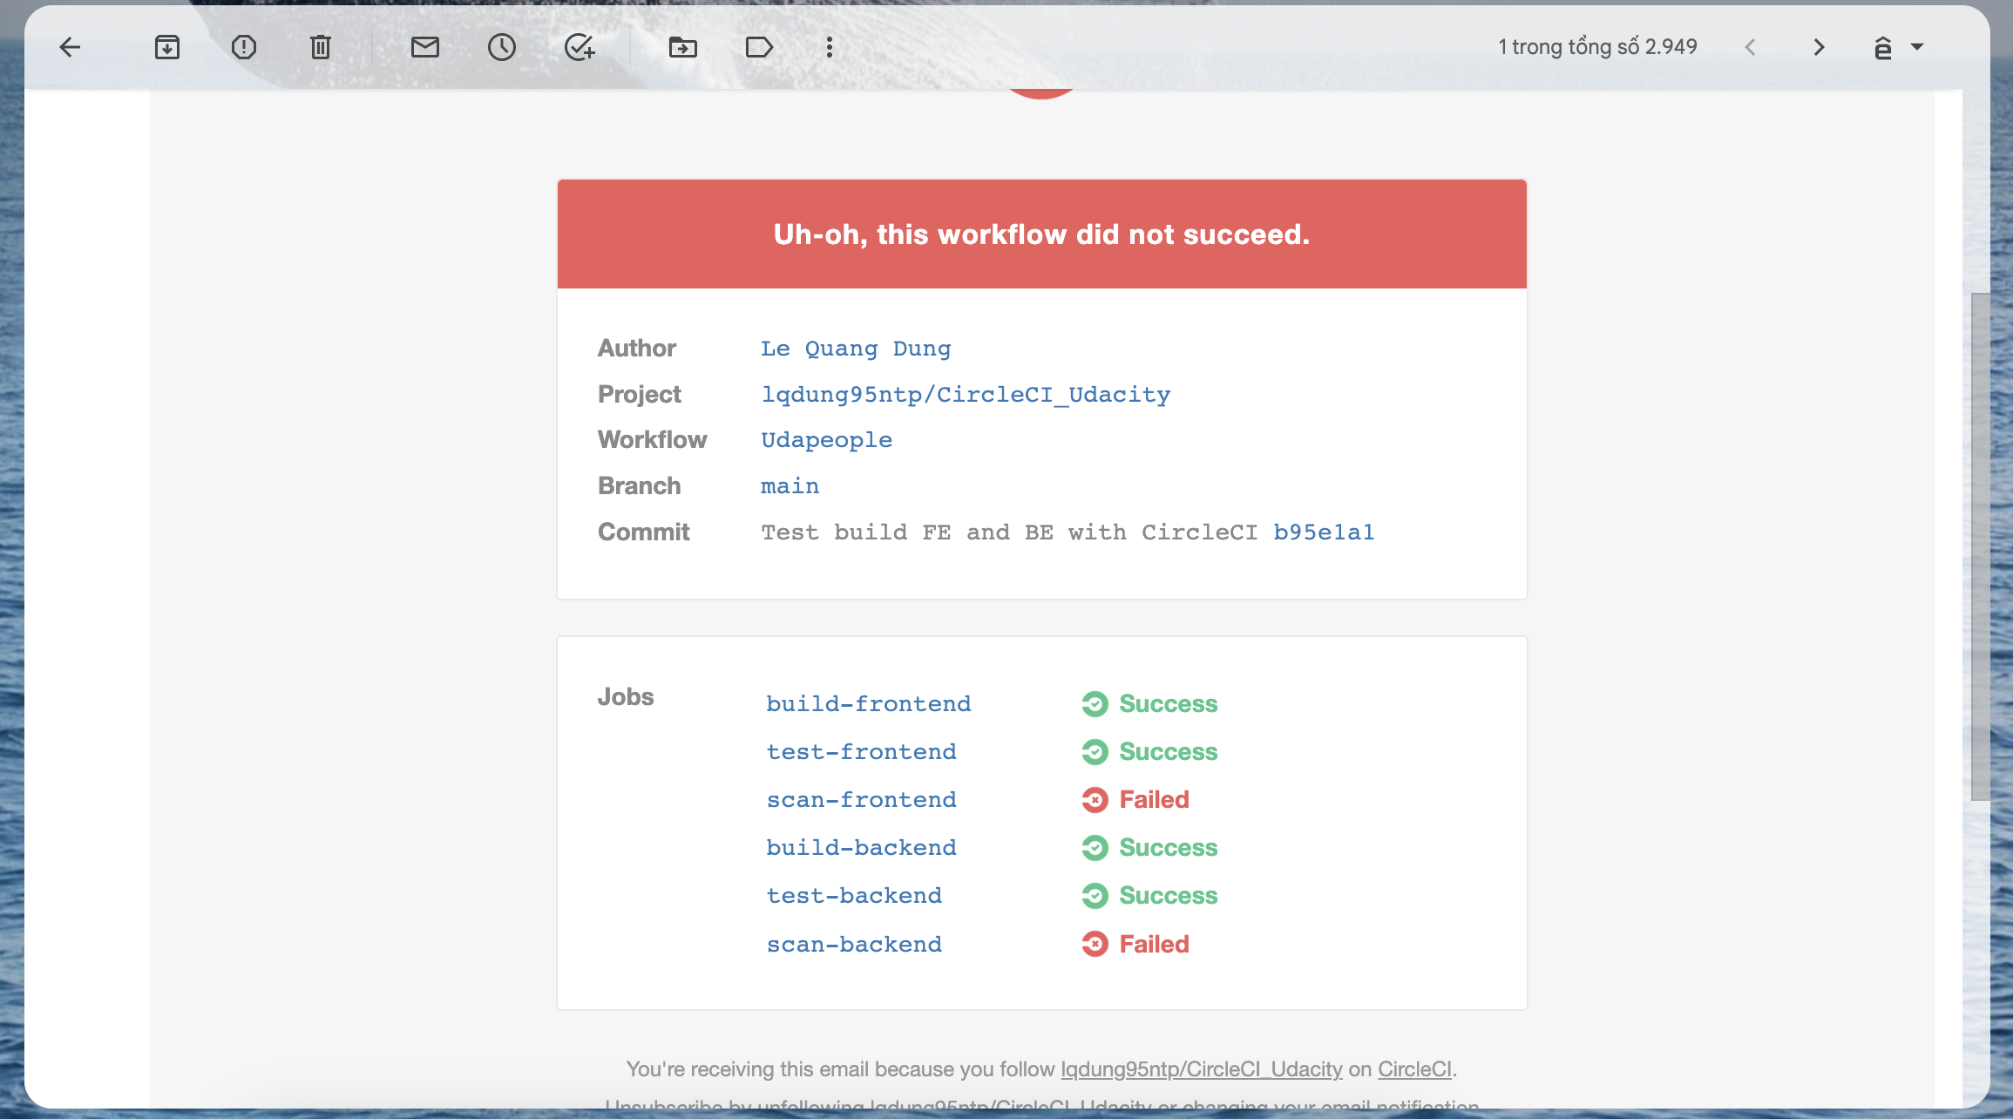

SCREENSHOT05:

SCREENSHOT06:

SCREENSHOT07:

SCREENSHOT08:

SCREENSHOT09:

SCREENSHOT10:

SCREENSHOT11:

* Free memory:

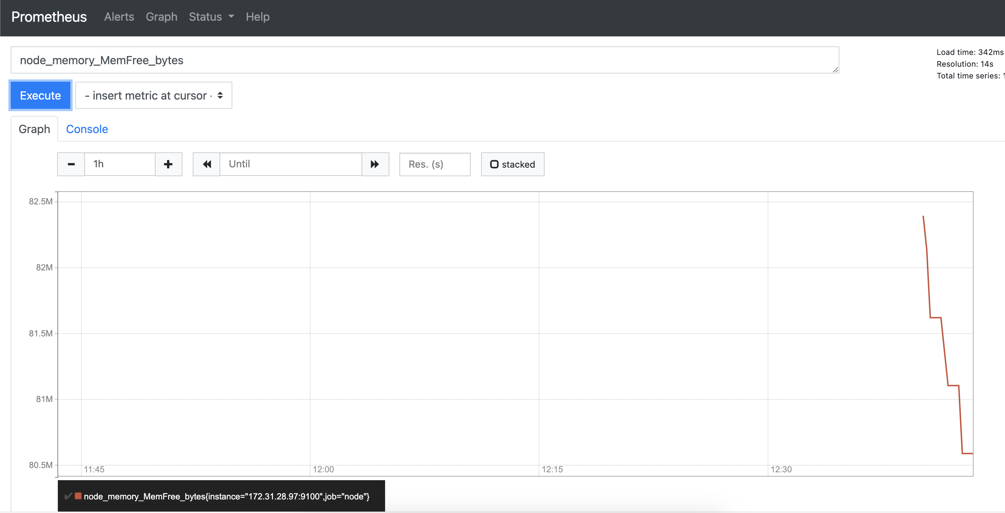

* CPU usage

* Disk usage

SCREENSHOT12:

URL03_SCREENSHOT:

URL04_SCREENSHOT:

URL05_SCREENSHOT:

